

| Business Template  **Introduction to Power BI** |
| --- |
|  |

## PART A

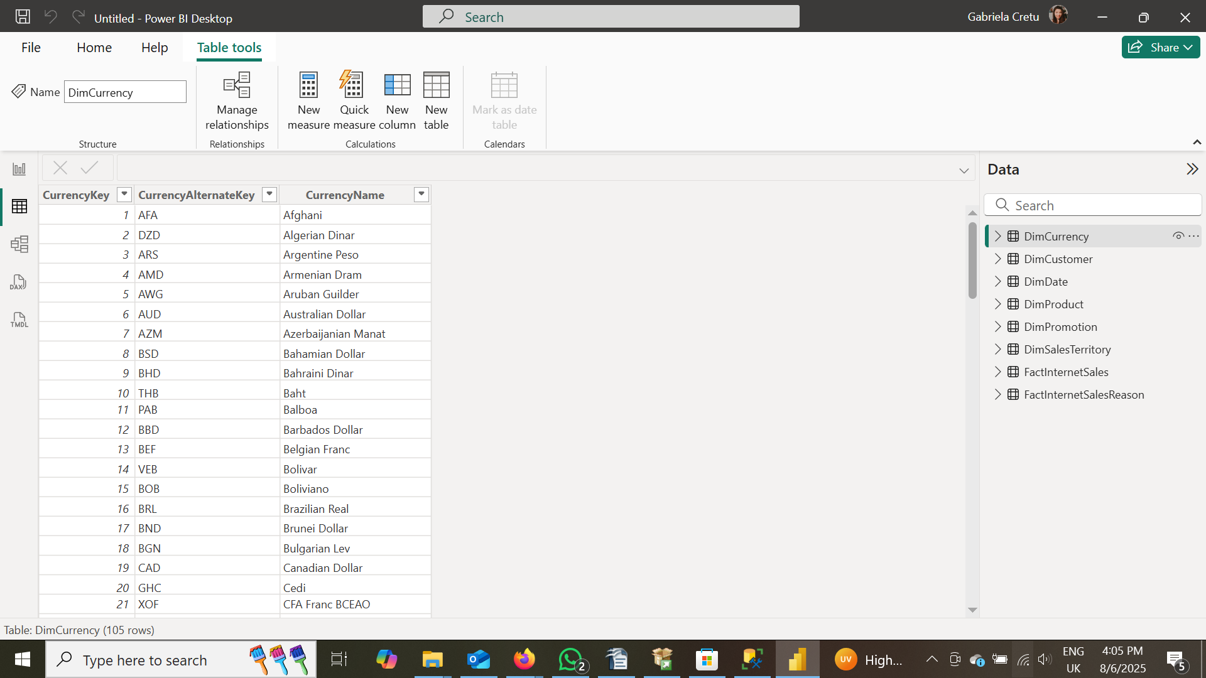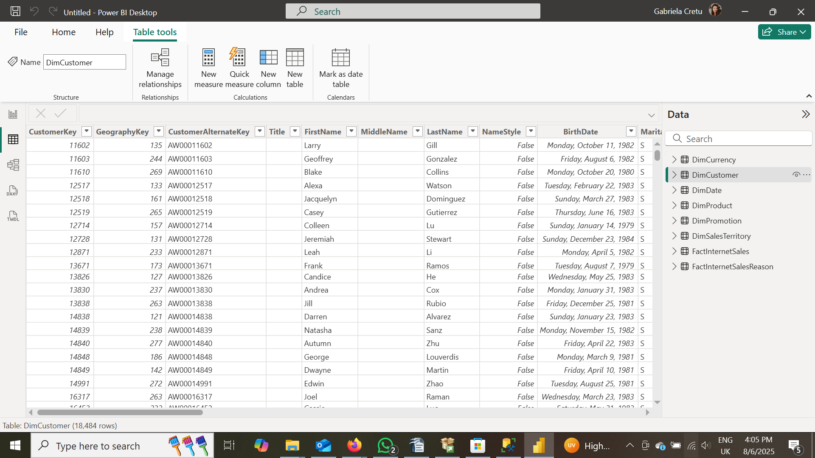

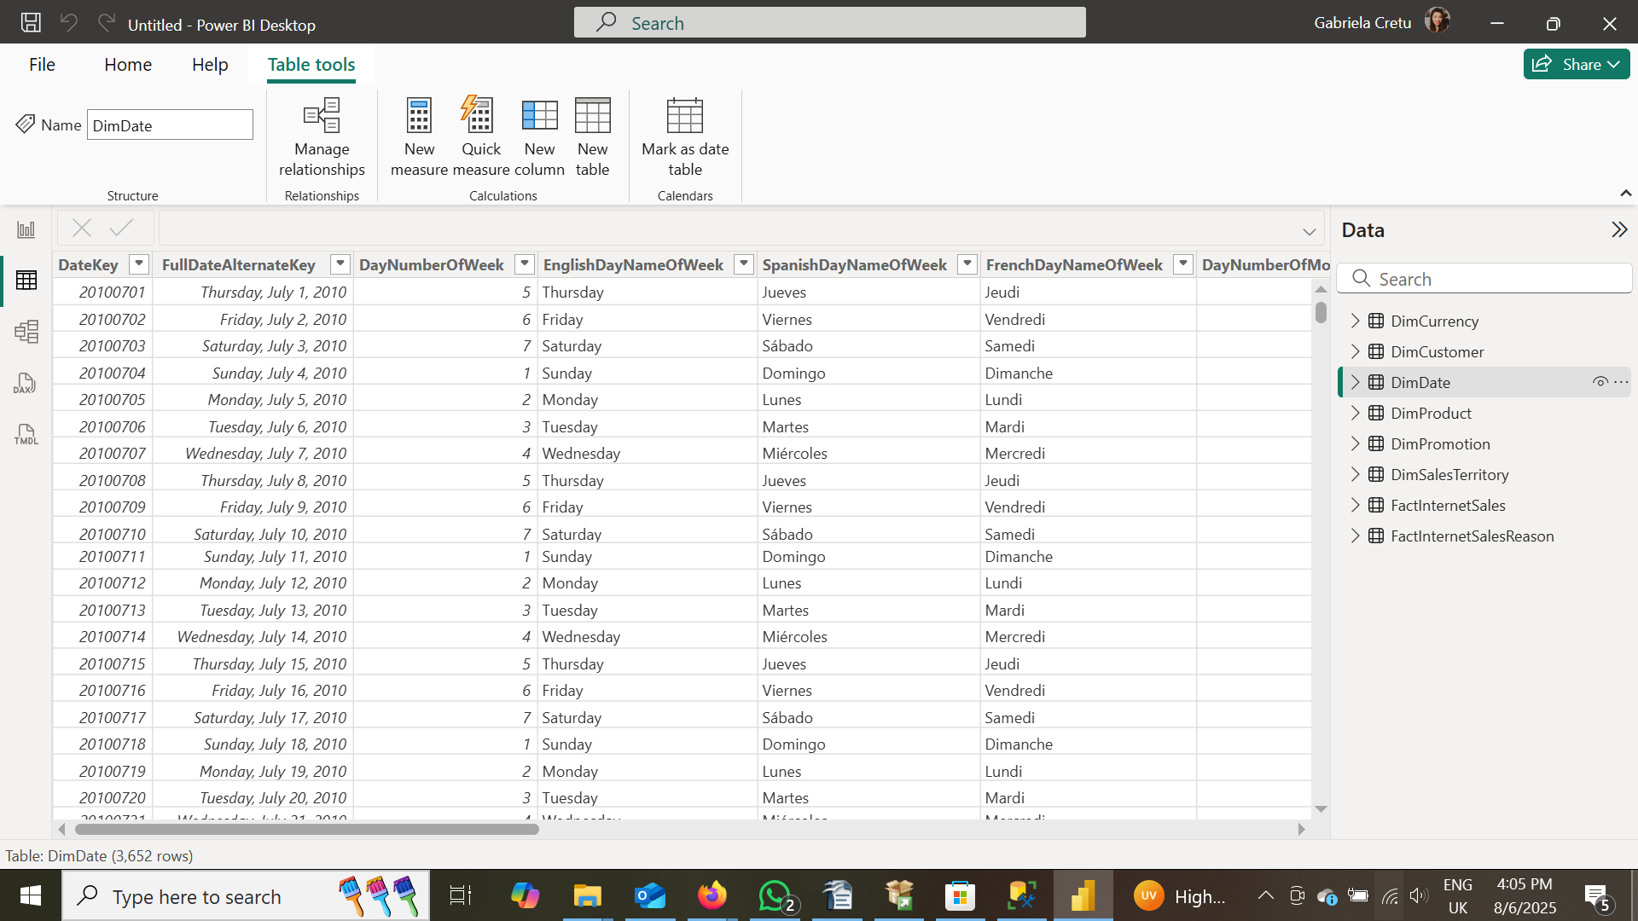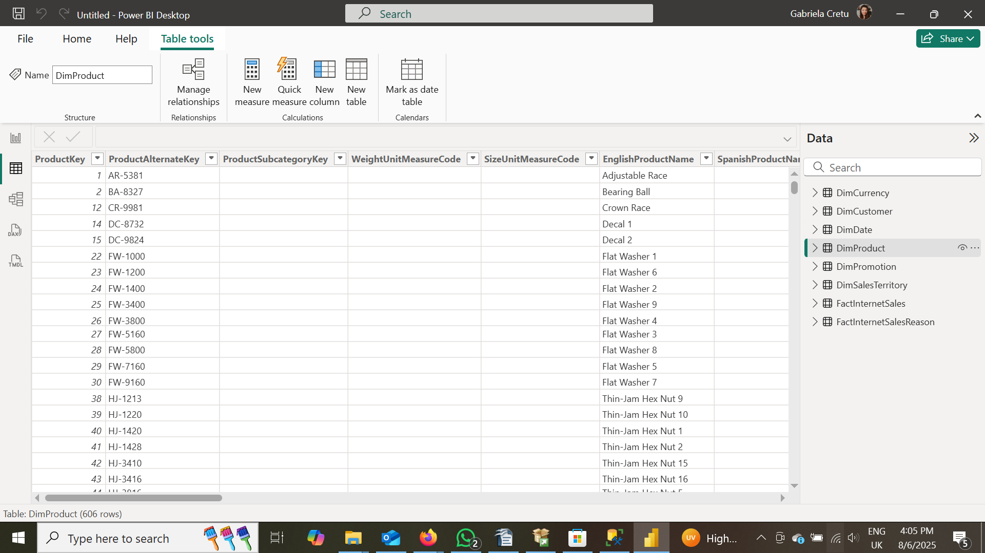

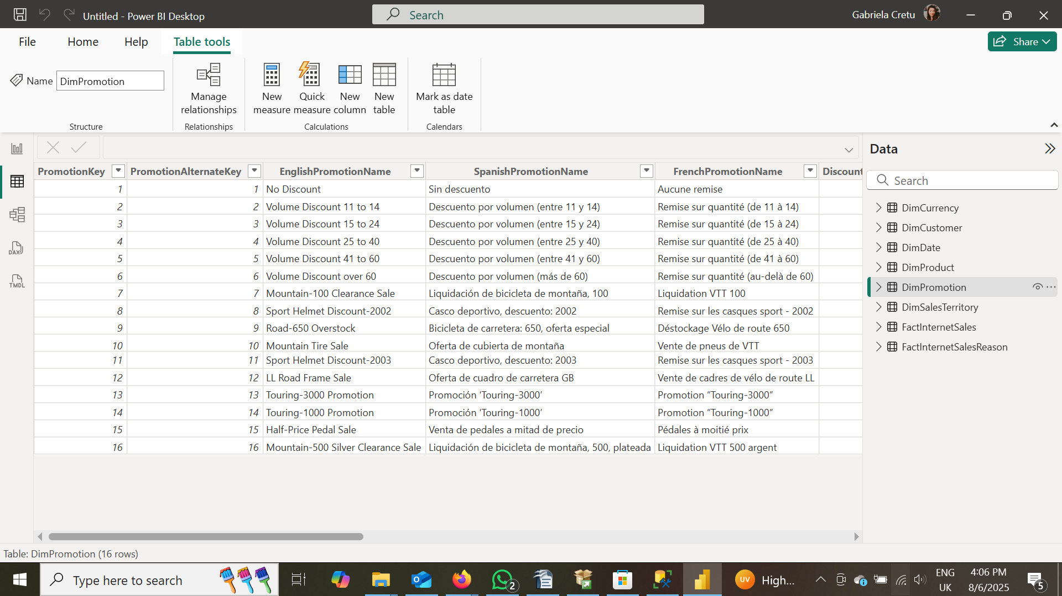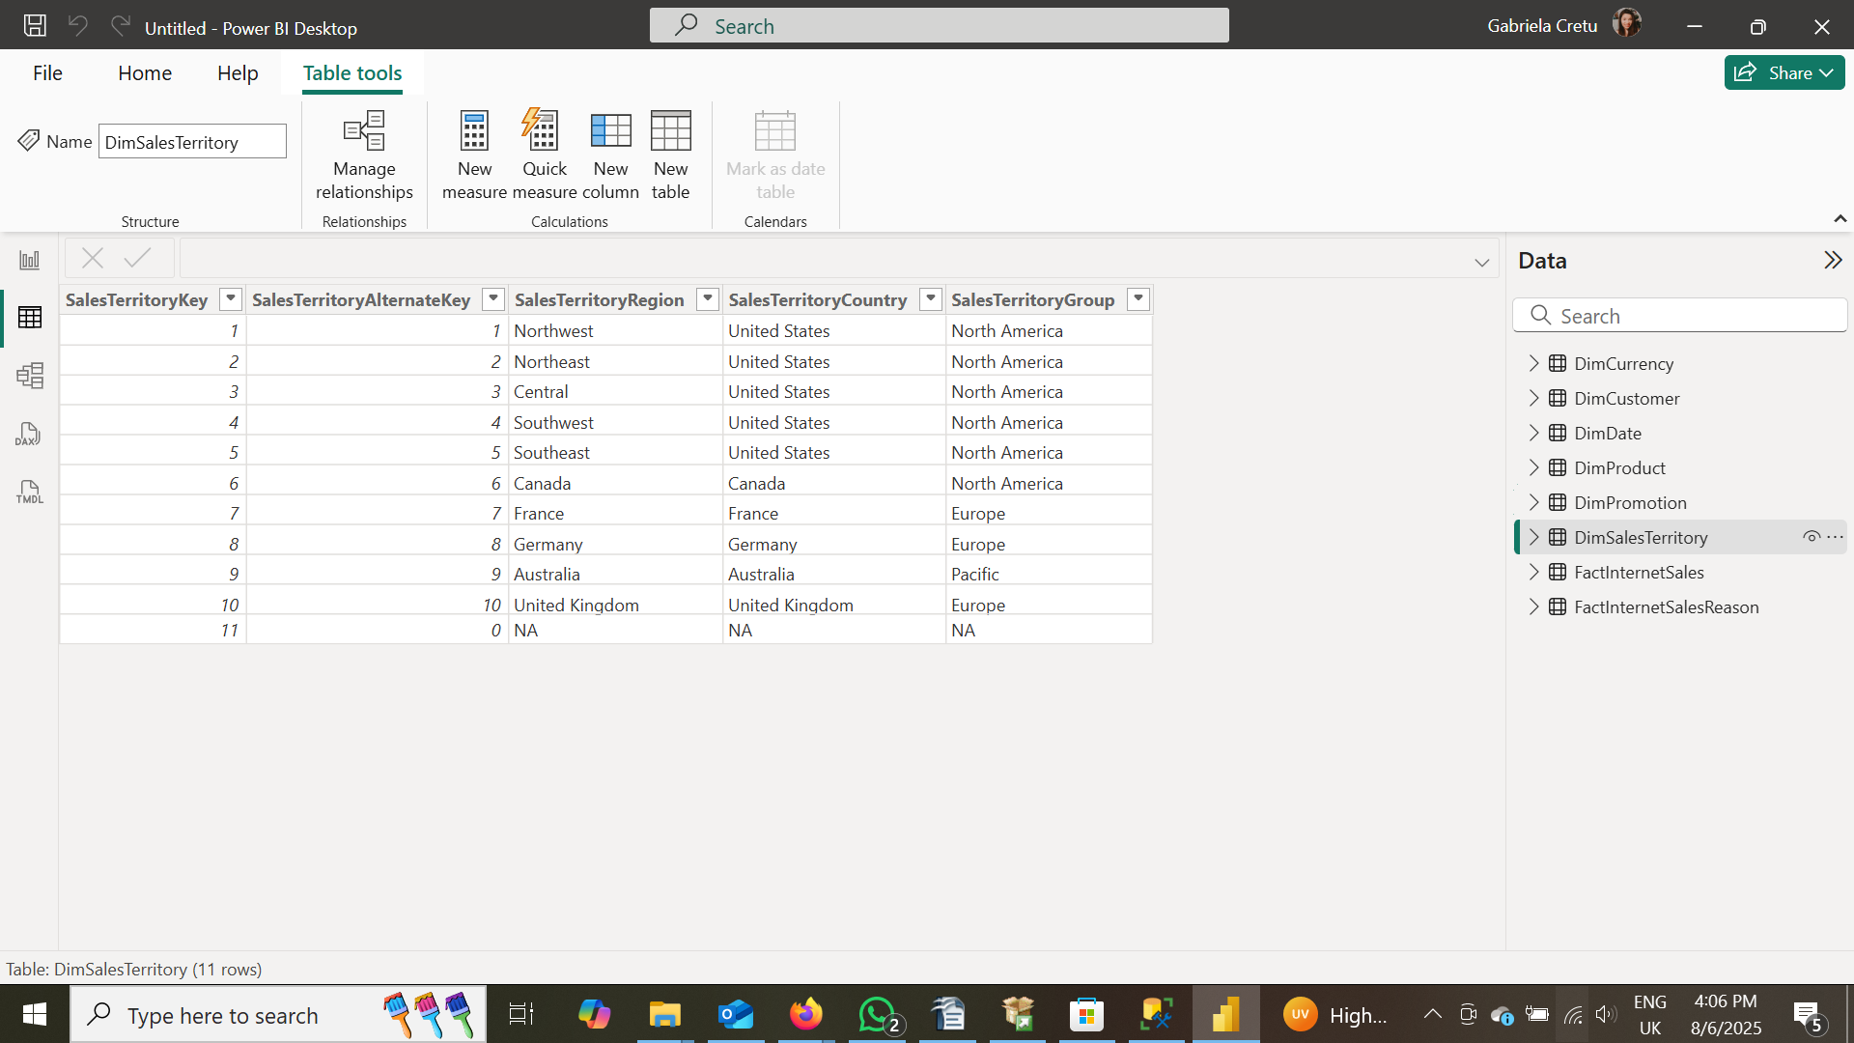

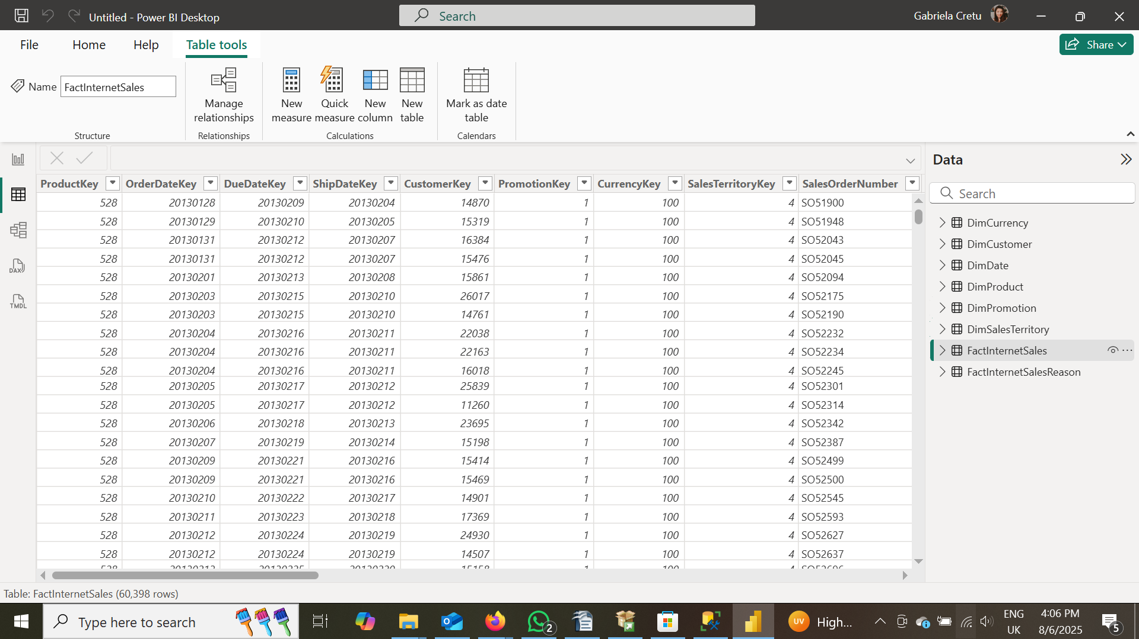

First, I duplicated the **First Name** and **Last Name** columns, then merged them to create a new column called **Full Name**.

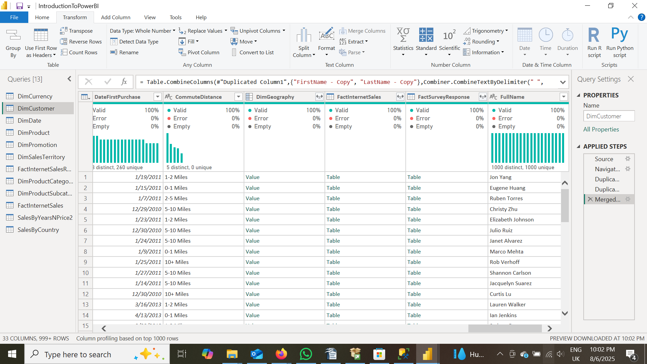

Next, I changed the data type of the **DiscountPct** column in the **DimPromotion** table to **Percentage**.

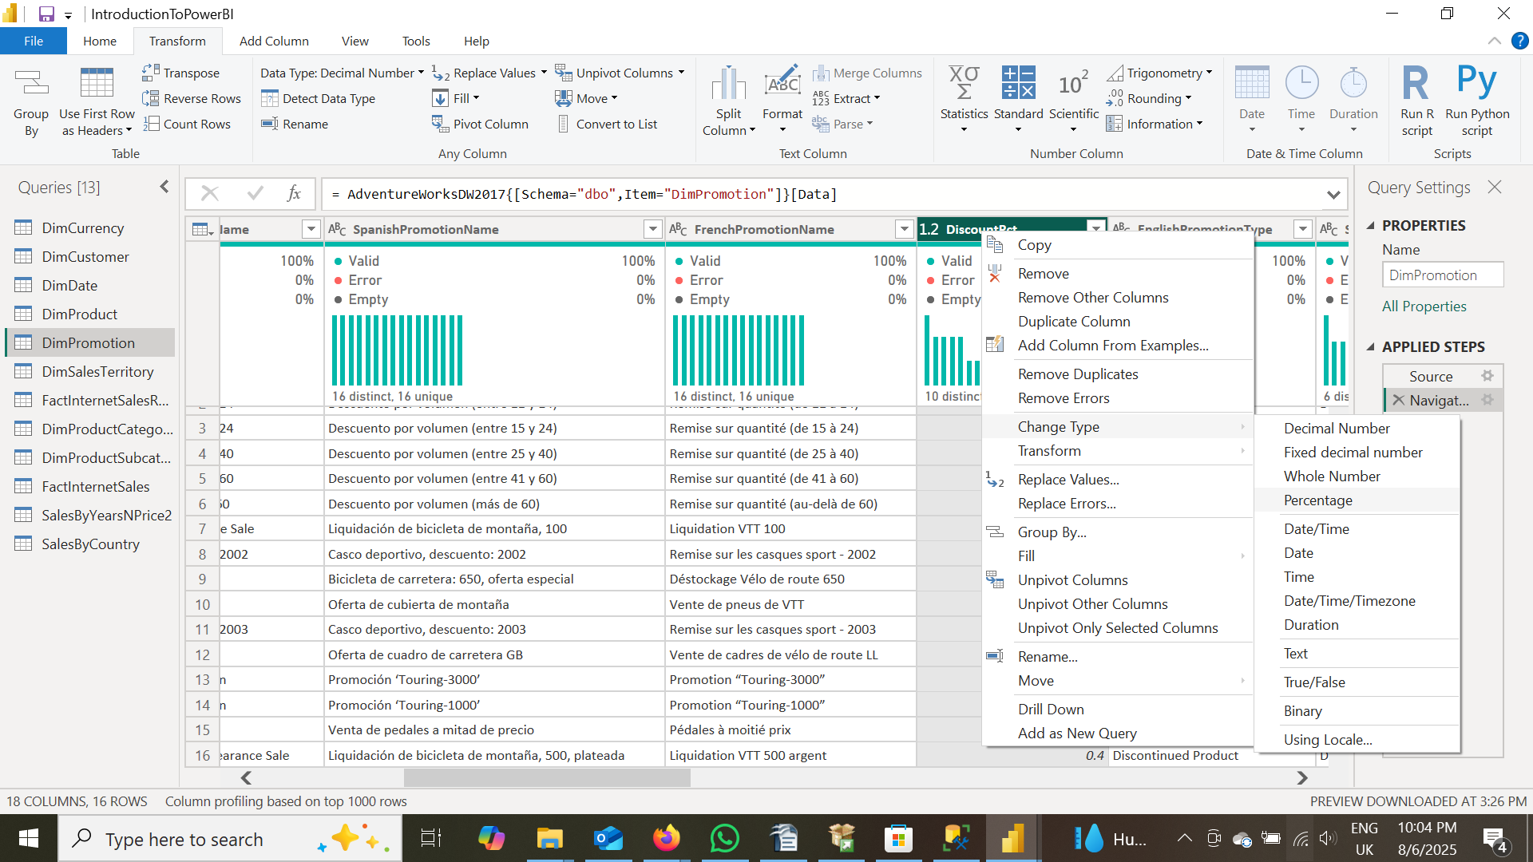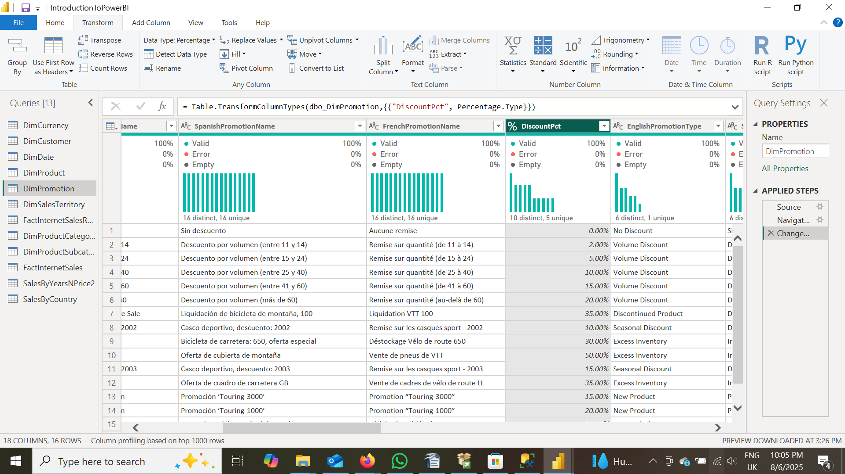

Following that, I added a new column by subtracting the **StartDate** from the **EndDate** of the promotions, and named it **DateSubtraction**.

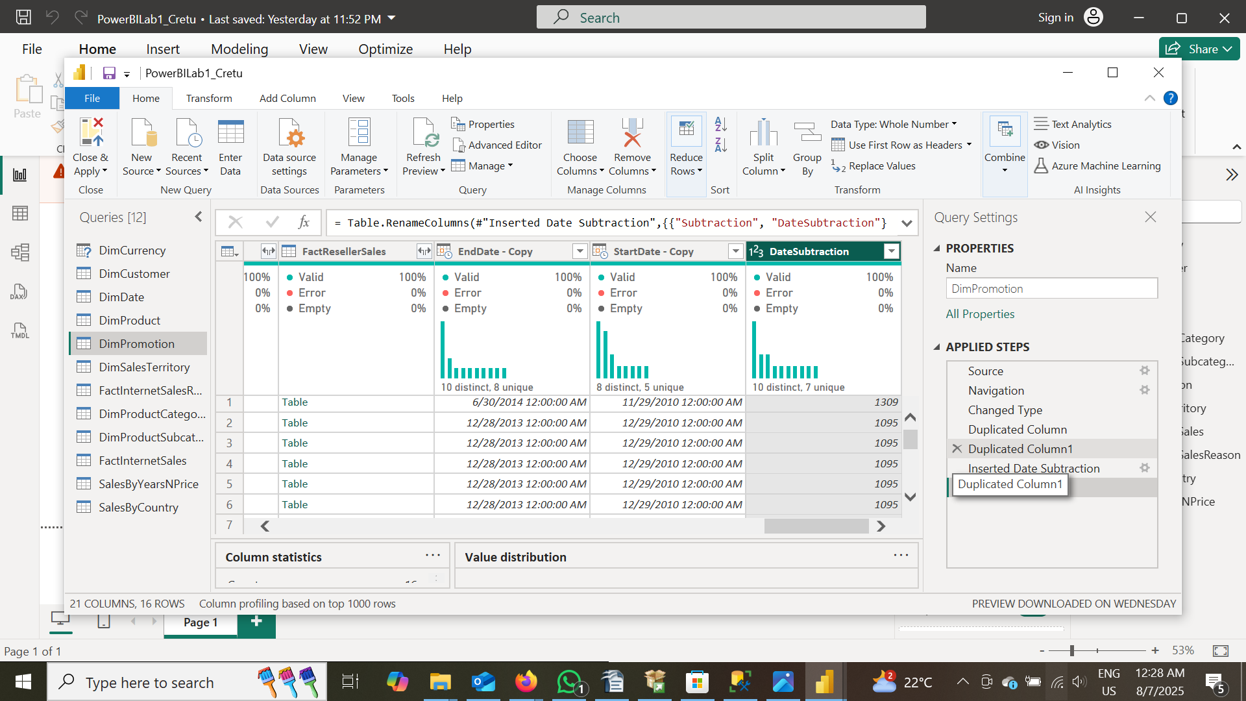

Next, I imported the additional tables **DimProductCategory** and **DimProductSubcategory** into the model.

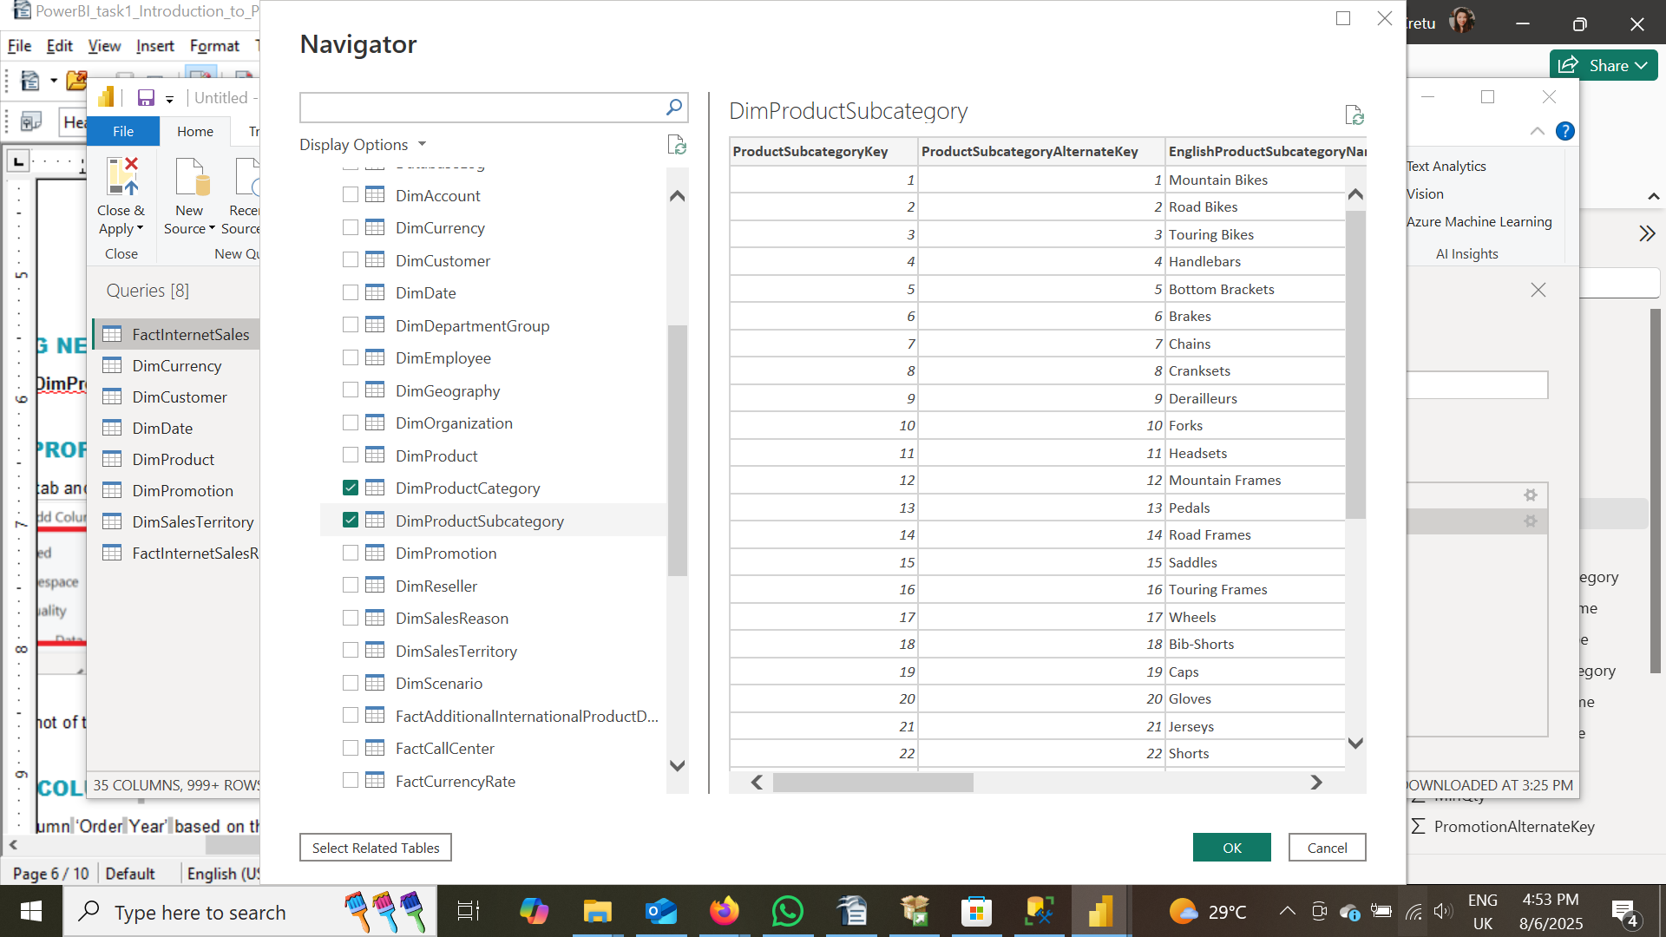

To profile the data, I reviewed the two tables by enabling the **Column Quality**, **Column Distribution**, and **Column Profile** features. This allowed for a detailed analysis of data distribution and helped verify the validity and completeness of the data.

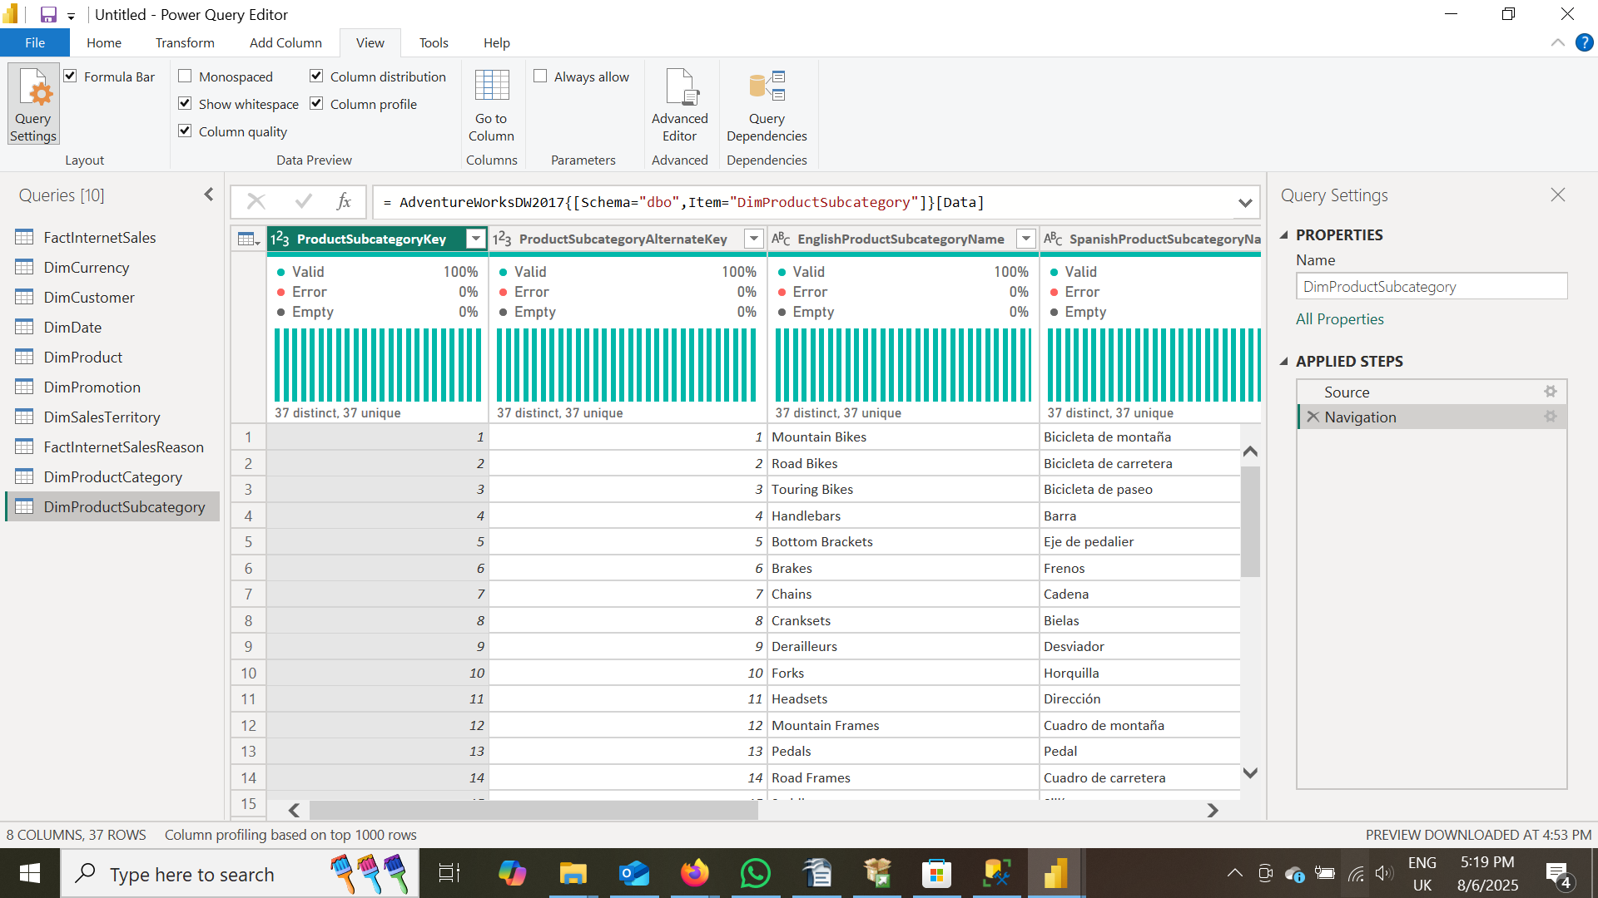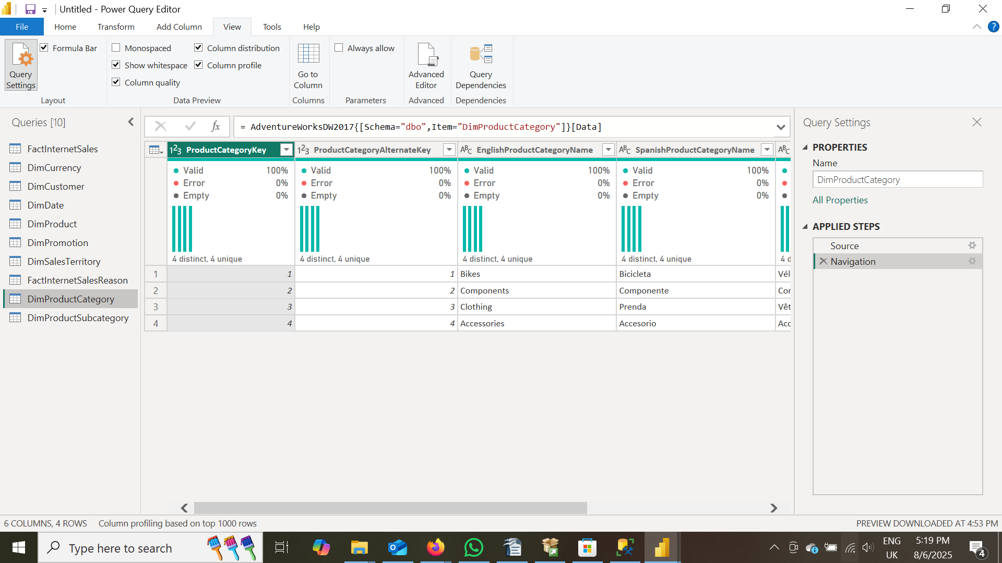

Next, we added a **Year** column by duplicating the original date column and transforming the duplicate to display only the year. This new column was named **OrderYear**.

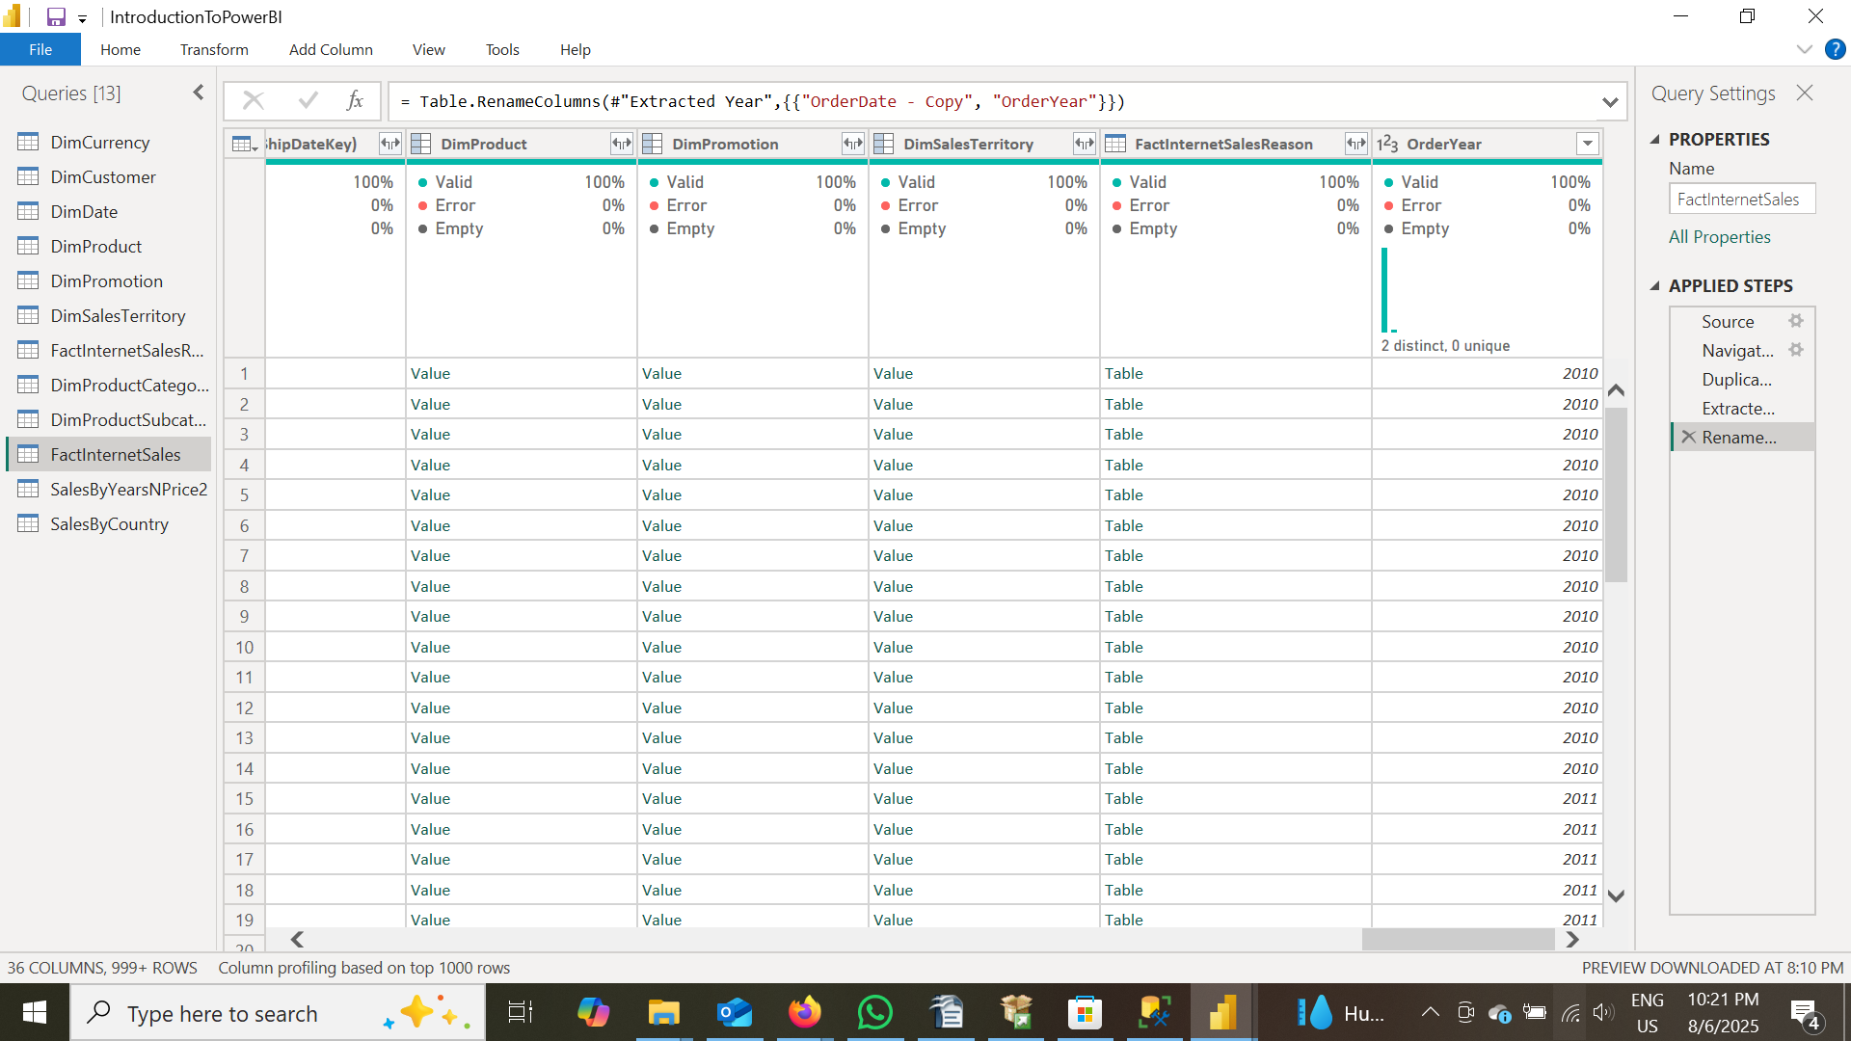

Next, we selected the columns **OrderYear**, **OrderQuantity**, **DiscountAmount**, and **SalesAmount** from the new **SalesByYearsNPrice** table, which was created as a reference from the **FactInternetSales** table, and removed all other columns.

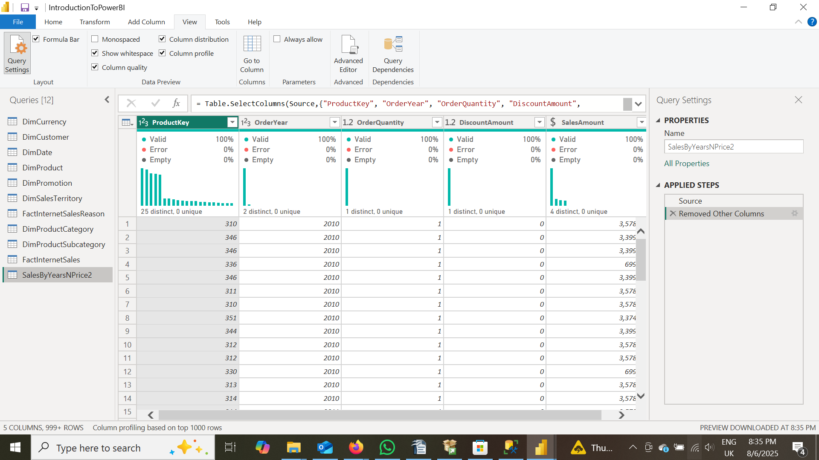

Next, we applied a **pivot transformation** by selecting the **OrderYear** column and pivoting the **SalesAmount** column based on it, in order to restructure the data into a **panel (wide) format**.

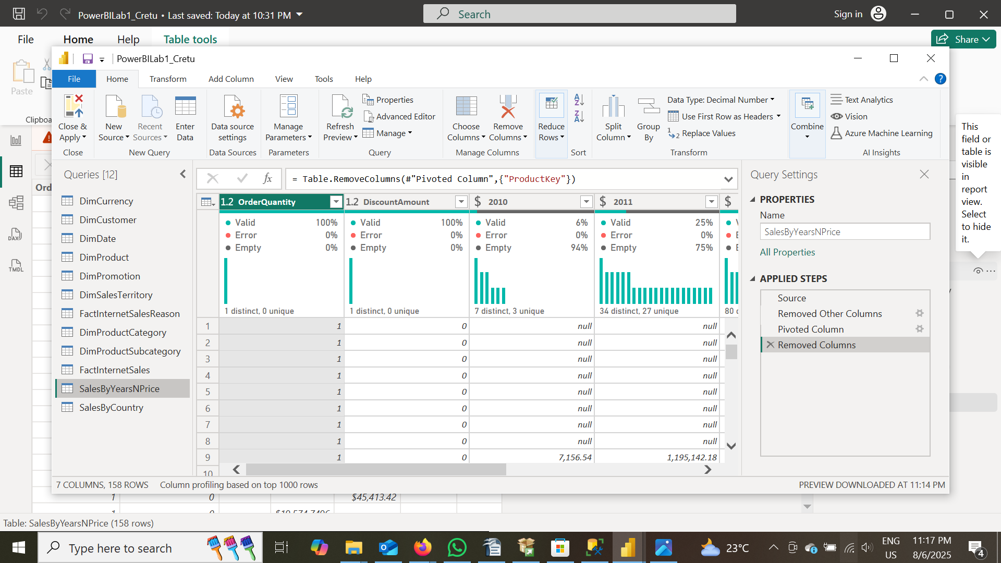

In this task, we primarily worked with **joins**. As in the previous task, we started by creating a new table called **SalesByCountry**, using **FactInternetSales** as the reference. Initially, we selected the columns: ProductKey, Order Year, SalesAmount, and SalesTerritoryKey.

Next, we performed a **left outer join** with the **DimSalesTerritory** table. After expanding the resulting table, we were able to retrieve the SalesTerritoryCountry column, as shown in the screenshot.

Following this, we sequentially joined three additional tables:

1. **DimProduct** on ProductKey
2. **DimProductSubcategory** on ProductSubcategoryKey
3. **DimProductCategory** on ProductCategoryKey

These joins ultimately allowed us to access the EnglishProductCategory column from the **DimProductCategory** table.

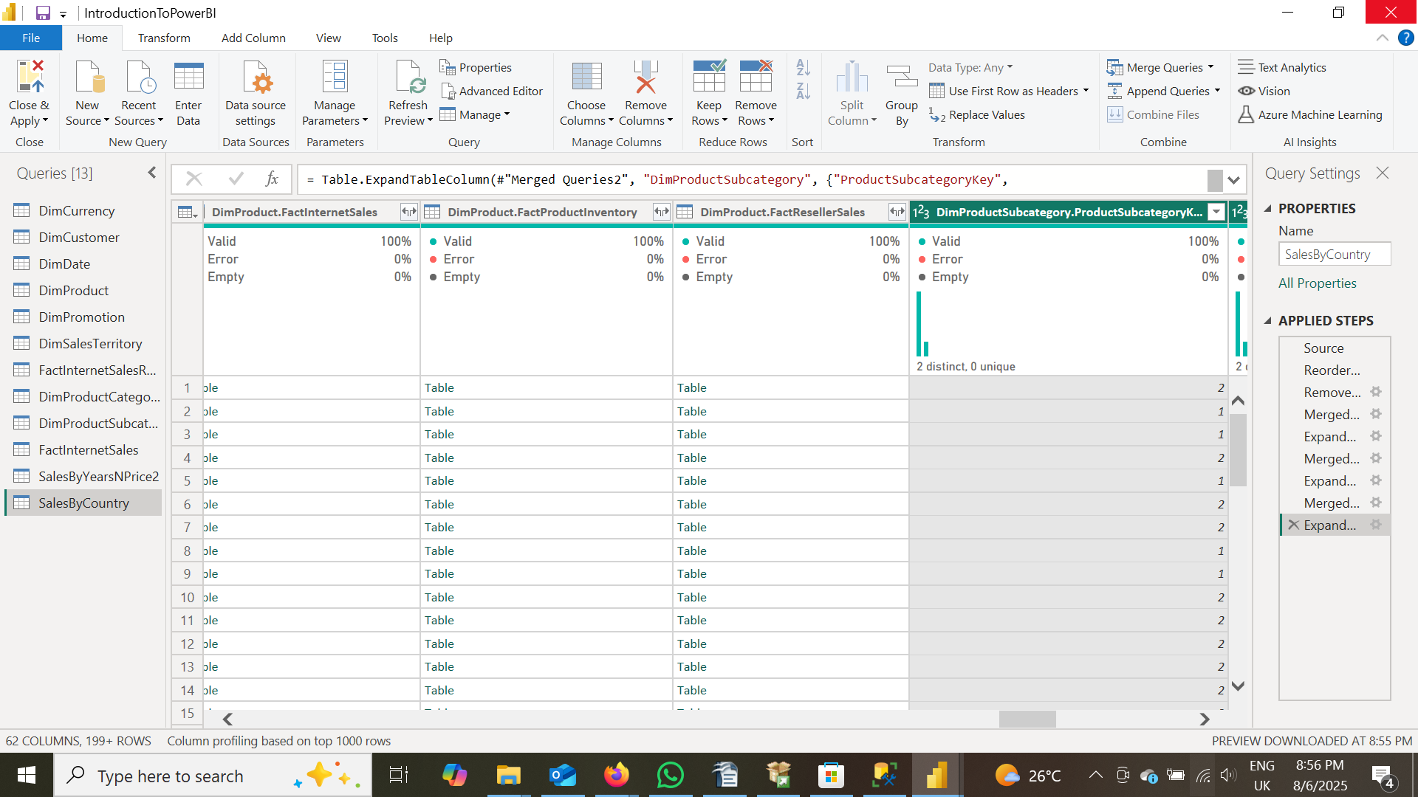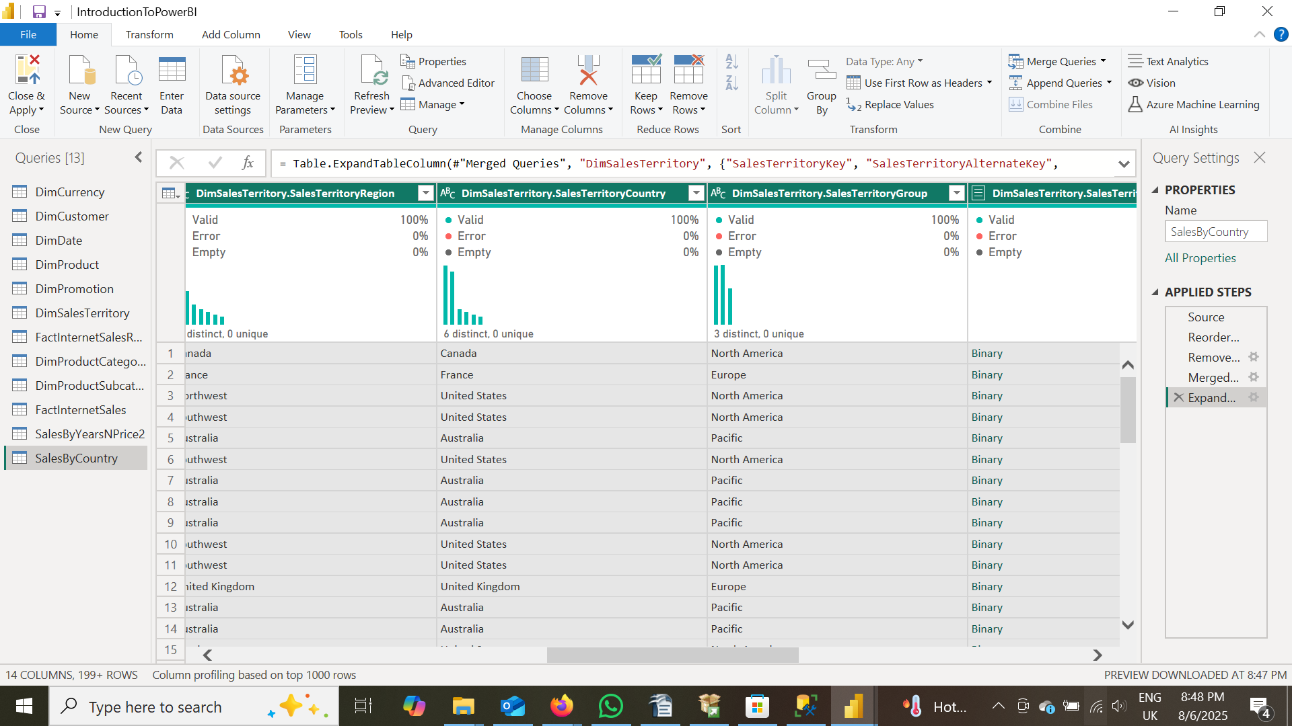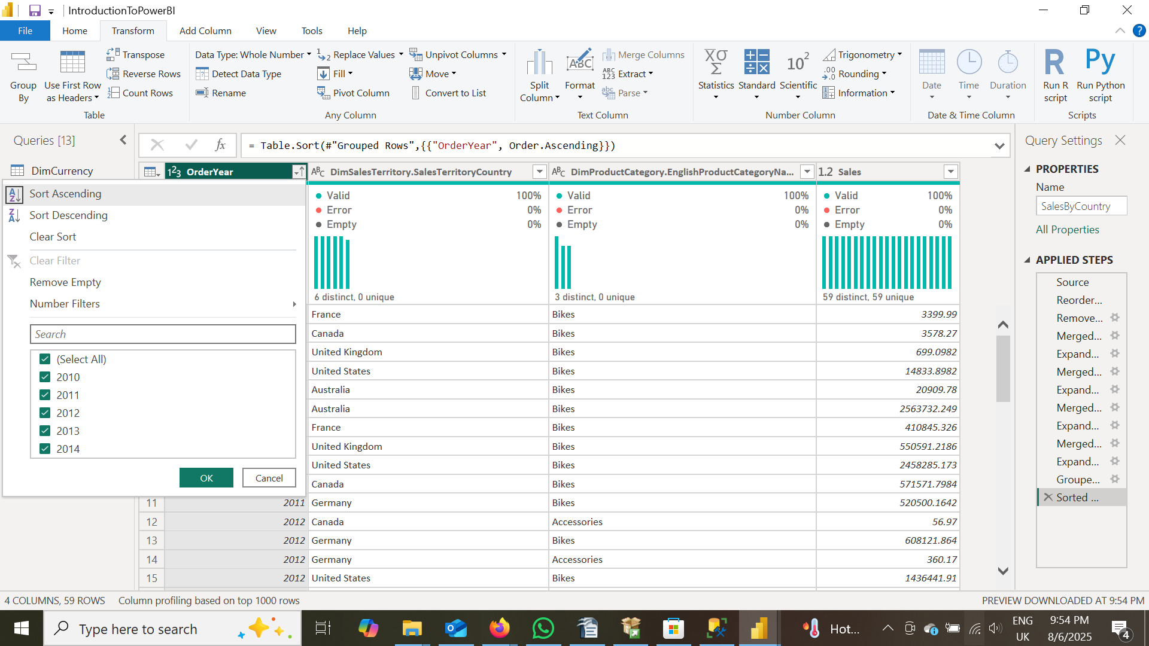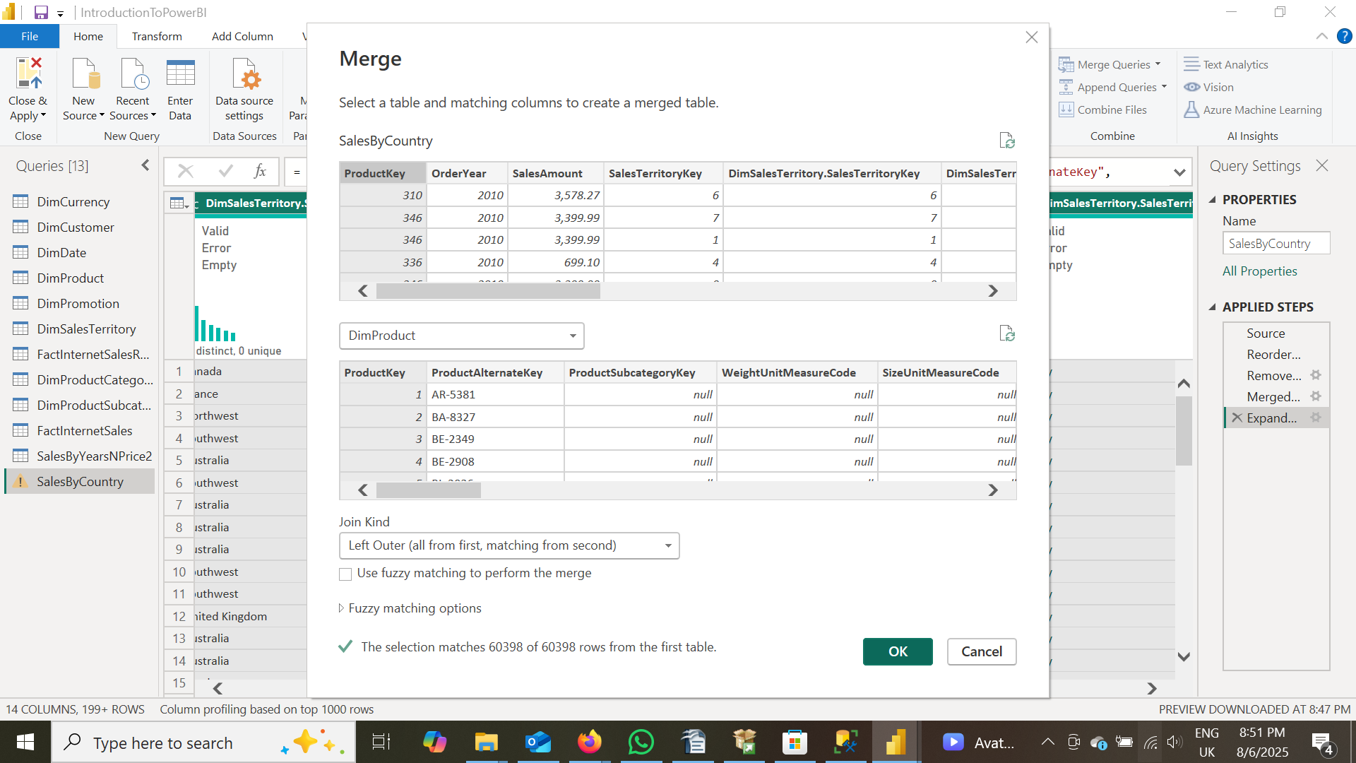

Next, we transformed the previously defined **SalesByCountry** table using the **Group By** function in Power BI. Specifically, we grouped the data by Order Year, SalesTerritoryCountry, and EnglishProductCategoryName.

For each unique combination of these three fields, we aggregated the data by **summing the SalesAmount**. This allowed us to easily retrieve the total sales for a specific year, within a particular sales territory, and for a given English product category.



## PART B

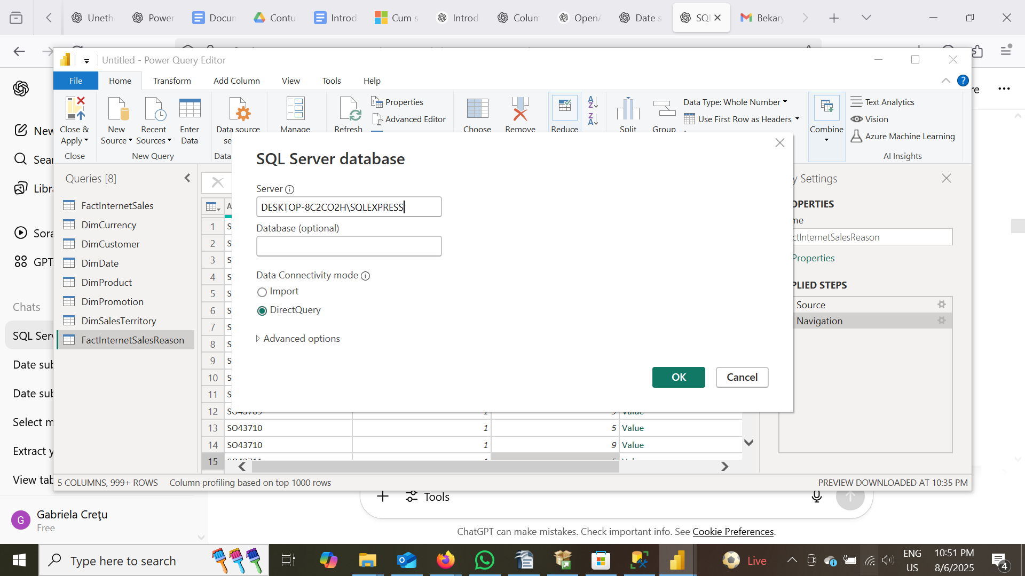

In this section, I loaded data using the **DirectQuery** option instead of the traditional **Import** method in Power BI. While most operations that previously worked with imported data continued to function properly, several others did not behave as expected under DirectQuery. Since many of the operations remained consistent, I will not include additional screenshots for those. However, I’ve included screenshots for the specific actions that failed.

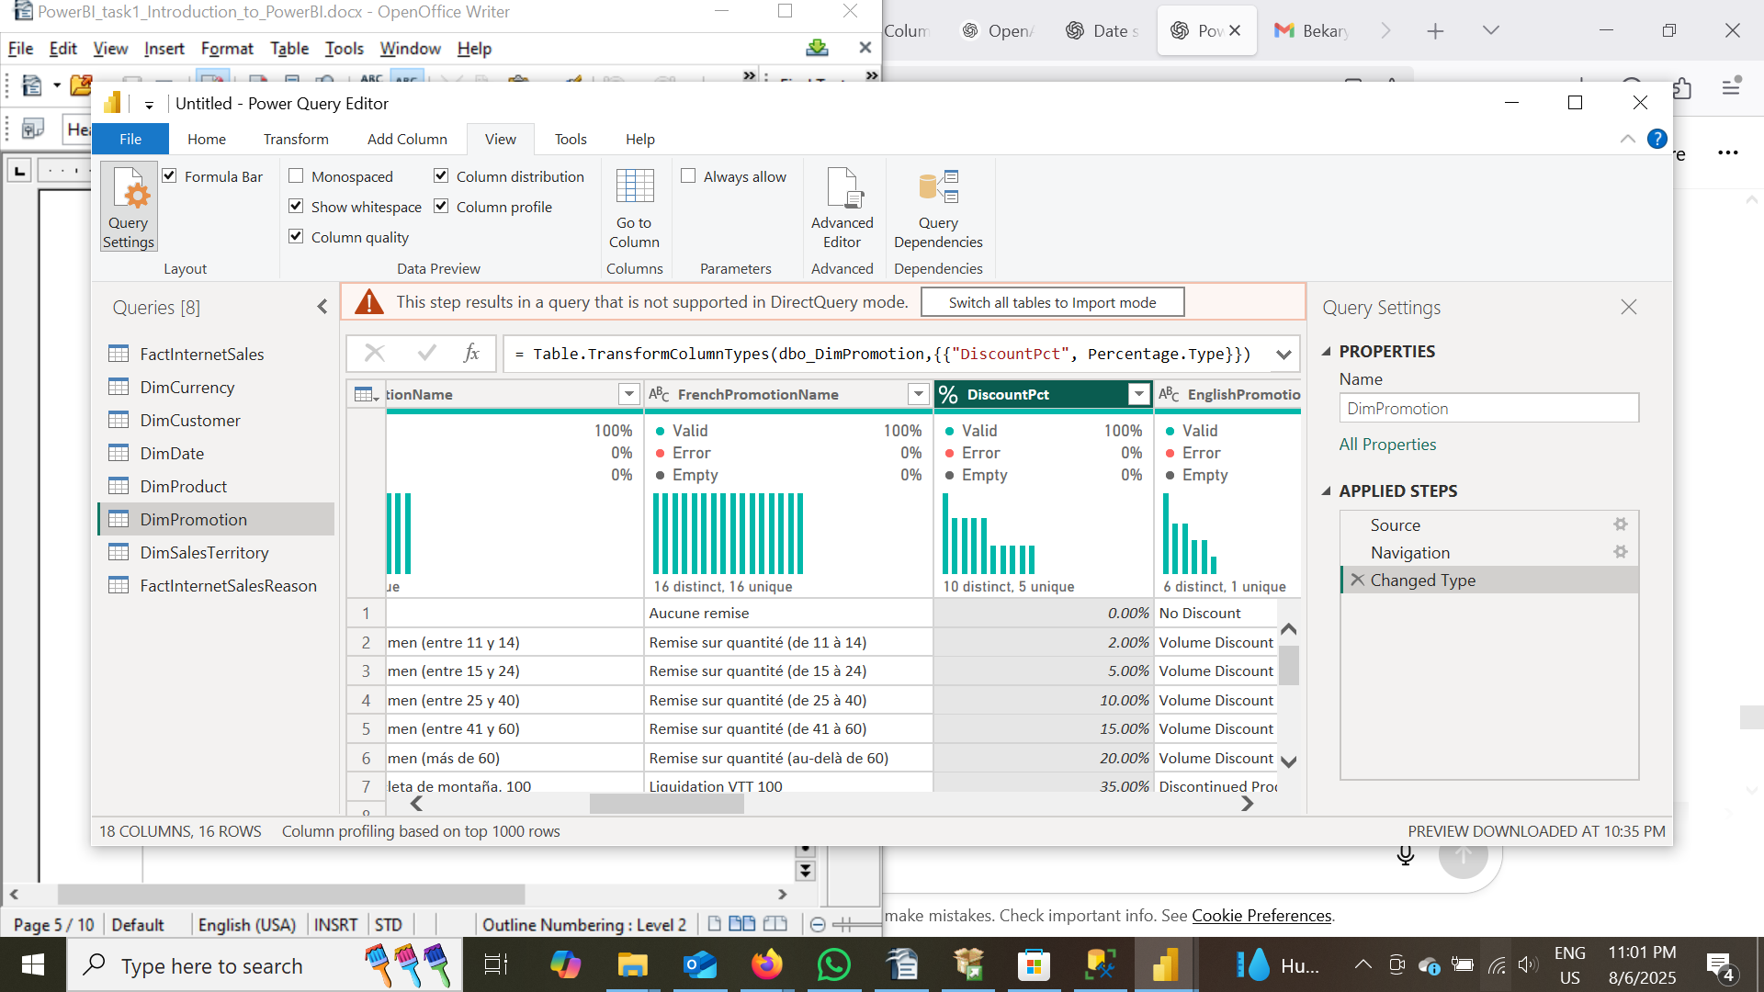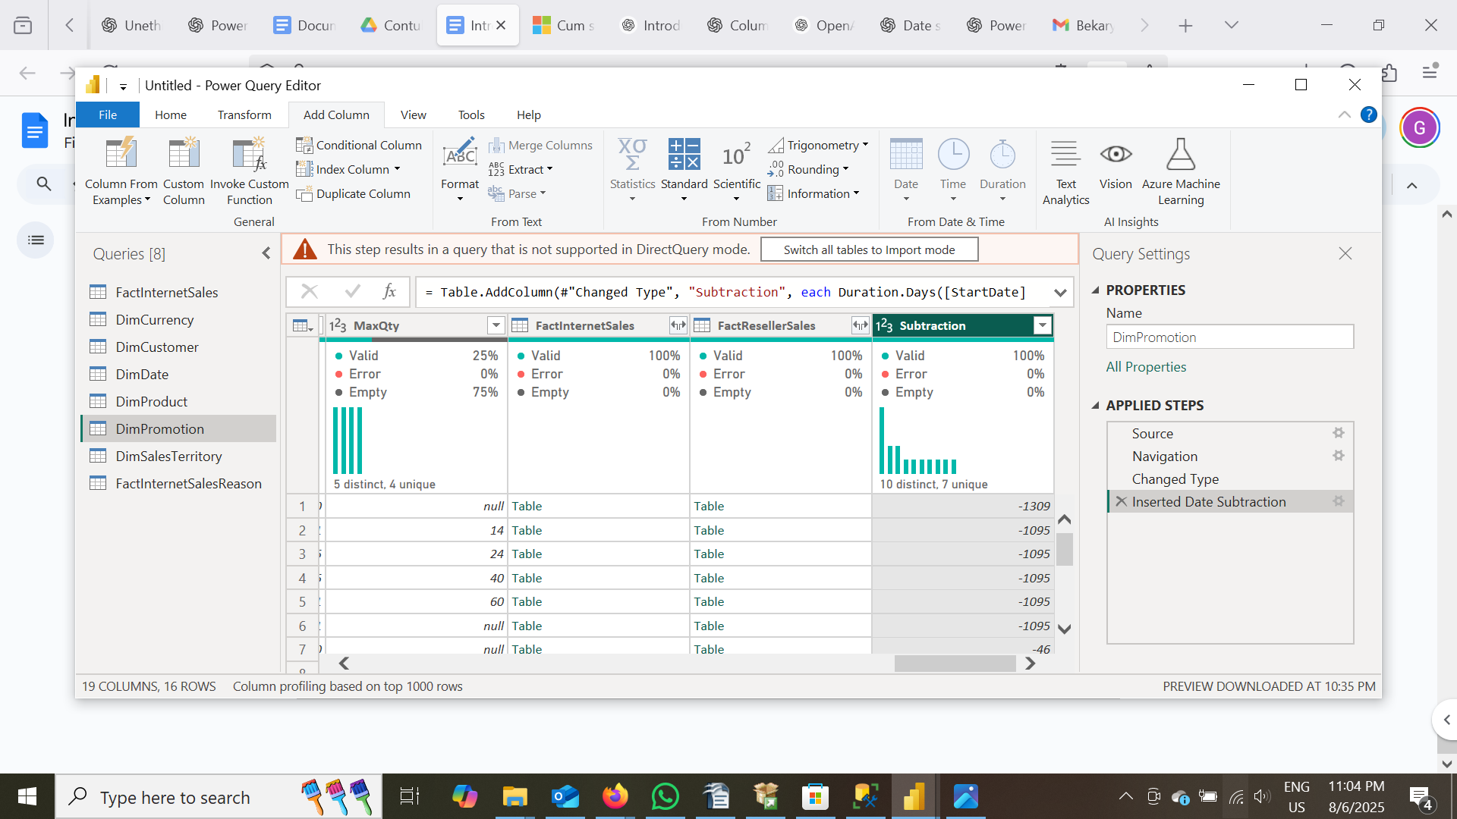

Notably, **arithmetic operations**—such as percentage conversions and subtraction—**failed when using DirectQuery**, even though they worked fine with imported data.

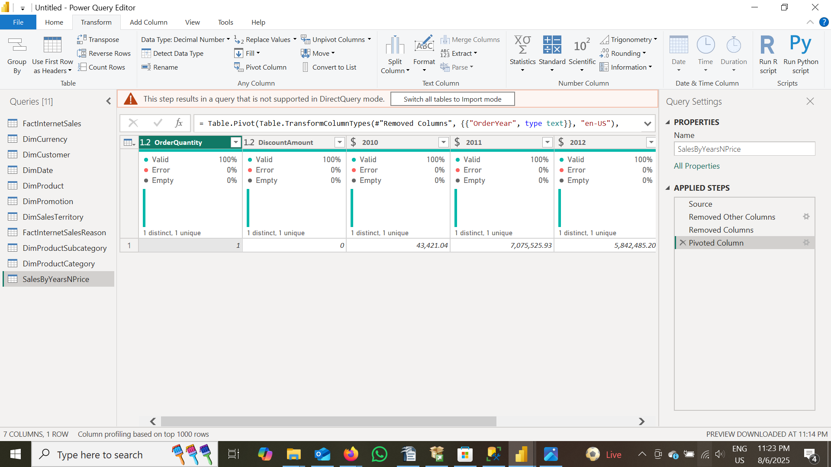

Additionally, **column pivoting** no longer functioned properly under the DirectQuery mode.

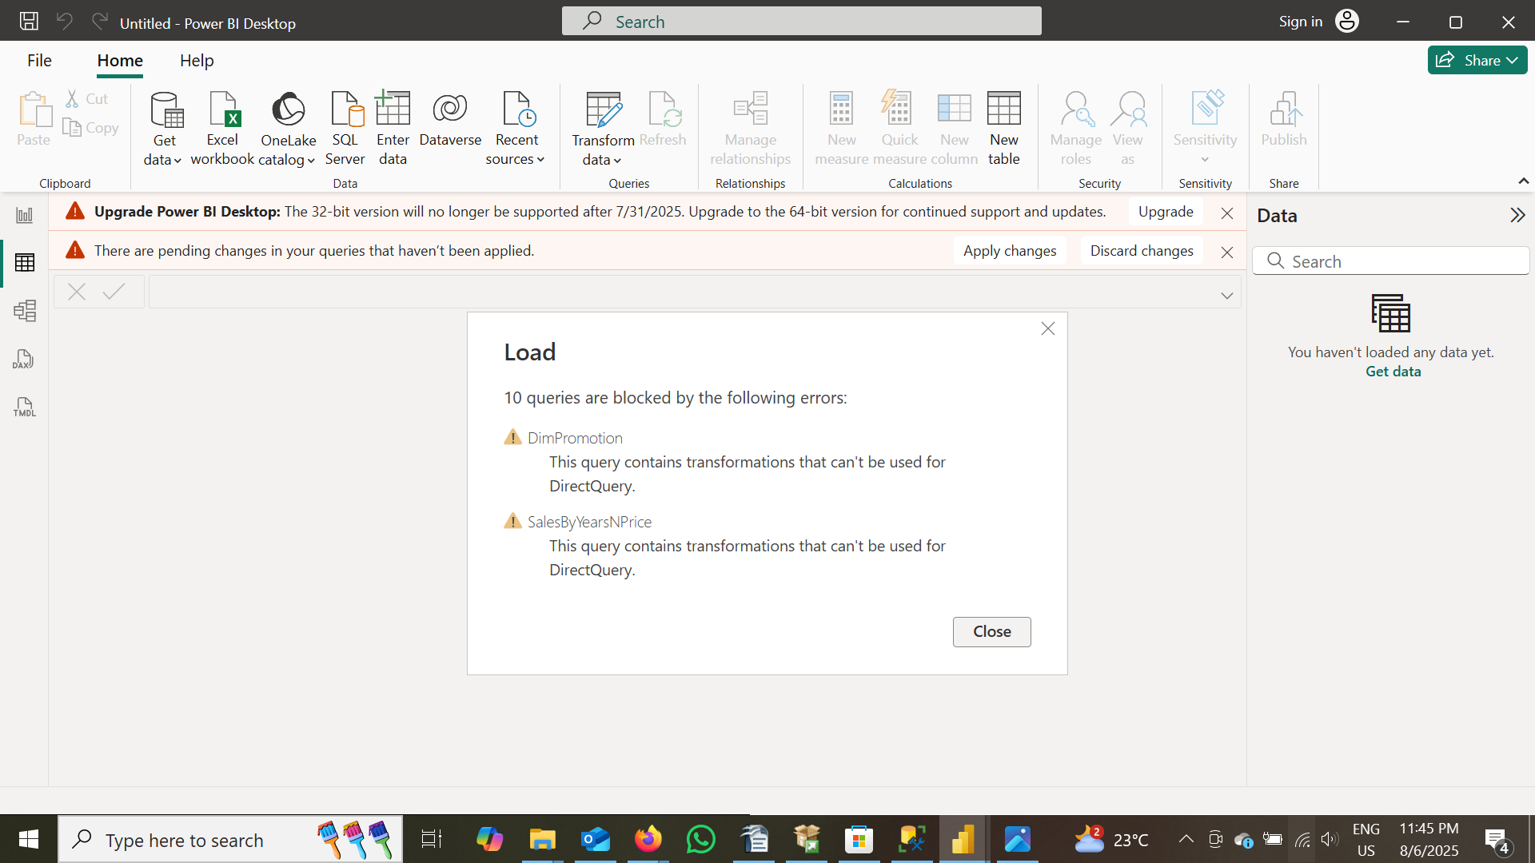

Finally, when attempting to **save the report**, the earlier errors prevented the environment from being saved successfully.

### Insights: Why These Issues Occurred

1. **DirectQuery Mode Limitations**:  
   * DirectQuery does not import data into Power BI but instead queries the source database in real-time.
   * As a result, certain transformations and calculated columns/measures that are computed in-memory during import cannot be processed the same way with DirectQuery.
2. **Arithmetic Operation Failures**:  
   * Simple calculations like subtraction or percentage change might rely on intermediate computed columns or complex query logic.
   * If the underlying data source doesn’t support the necessary SQL operations or if Power BI can't translate the operation into a valid SQL query, the operation will fail.
3. **Pivoting Columns**:  
   * Pivoting often requires reshaping data in memory, something that’s trivial with imported data.
   * With DirectQuery, these operations may require complex SQL (e.g., using PIVOT) that Power BI may not generate automatically or that your source system does not support efficiently.
4. **Save Failures**:  
   * Power BI may prevent saving if there are unresolved errors in queries or transformations, particularly when it cannot validate or execute those steps in real time due to DirectQuery limitations.

## PART C

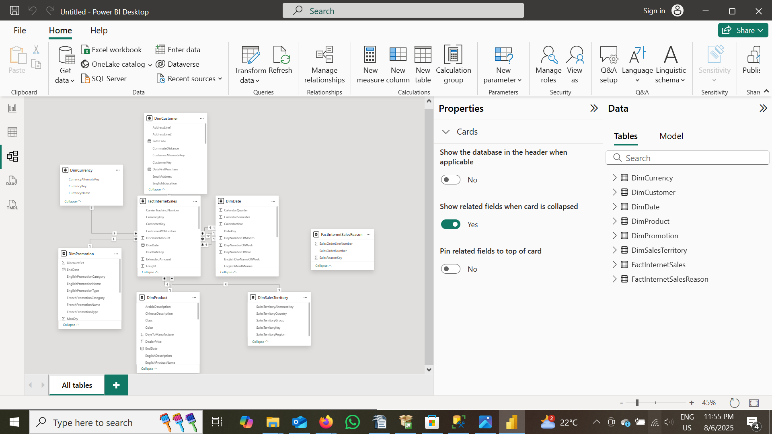Upon reviewing the data model, we found that most relationships exhibit a **one-to-many cardinality**, with the **dimension tables** on the "one" side and the FactInternetSales table on the "many" side. Each dimension table typically has **one active relationship** with the fact table. The only exception was the DimDate table, which had **three relationships** with FactInternetSales — linked via OrderDate, DueDate, and ShipDate. Among these, **two were inactive** and **one was active**.

Since our analysis will be based solely on **OrderDate**, we made the relationship between FactInternetSales[OrderDate] and DimDate[DateKey] **active** and **removed the other two** relationships. This change ensures that all time-based analysis references a single, consistent date field.

In terms of **cross filter direction**, all relationships are set to **single direction**, flowing from the dimension tables to the fact table, which is appropriate for a star schema and supports efficient filtering and aggregation.

All other relationships between the fact and dimension tables are **active, one-to-many, and single-directional**, confirming a well-structured data model. Additionally, the FactInternetSalesReason table is present in the model but is **not connected** to any other table at this time.